Love Patel

C964 Task 2: Design and Development  
Capstone Project

**Letter of Transmittal**

Love Patel  
1234 Innovation Way  
Technology Park, CA 94043  
Email: [lpate22@wgu.edu](mailto:lpate22@wgu.edu)  
Phone: (555) 123-4567  
November 25, 2023

John Doe  
Director of Technology Innovation  
Western Governors University  
4001 South 700 East  
Salt Lake City, UT 84107

Dear Mr. Doe,

I am thrilled to present the enclosed proposal for the Weather Pattern Analysis and Prediction Project, developed as part of my capstone project at Western Governors University. This proposal targets the pressing need for precise and reliable weather forecasting across various sectors, with a focus on agriculture and event planning.

Within this document, you will find a comprehensive plan detailing the development of a data product leveraging advanced machine learning techniques for enhancing weather prediction accuracy. The proposal covers the project’s objectives, methodology, anticipated benefits, and ethical considerations, as well as my relevant expertise in the field.

I firmly believe that this project will substantially improve decision-making processes in weather-dependent industries and am keen to discuss its potential impact and implementation strategies with you.

Sincerely,

Love Patel

**Project Proposal for Weather Pattern Analysis and Prediction**

Executive Summary

**Problem Summary**: In sectors such as agriculture and event planning, the reliance on accurate weather predictions is paramount. However, current forecasting methods often lack the desired precision and timeliness, leading to inefficient planning and resource allocation.

**Data Product Benefits**: Our proposed solution offers precise, data-driven weather predictions. By leveraging advanced machine learning techniques, it enables better strategic planning and efficient resource management, thus mitigating risks associated with unpredictable weather conditions.

**Outline of Data Product**: The product is a sophisticated machine learning tool designed to analyze historical weather data and accurately forecast future weather conditions. This tool will incorporate various weather parameters, providing comprehensive and reliable predictions.

Project Description

**Data Used**: The project will utilize publicly available weather datasets, incorporating various parameters such as temperature, humidity, and precipitation. These datasets provide a rich source of historical weather data, essential for training our predictive models.

**Objectives and Hypotheses**: Our primary objective is to develop an accurate and reliable predictive model for weather conditions. We hypothesize that the application of machine learning models will significantly enhance the accuracy of weather predictions compared to traditional forecasting methods.

**Project Methodology**: The project will encompass several key phases:

* **Data Acquisition**: Sourcing relevant historical weather data from public databases.
* **Data Preprocessing**: Cleaning and structuring the data to suit model requirements.
* **Model Training**: Utilizing supervised learning algorithms to train the model on historical data.
* **Evaluation**: Assessing the model’s accuracy and reliability through rigorous testing.

**Funding Requirements**: To successfully execute the Weather Pattern Analysis and Prediction project, the following budget is estimated:

* **Software Licenses**:
  + Python and relevant libraries (free, open-source)
  + Advanced Data Analysis Tools: $500 (for any specialized software not covered by open-source solutions)
* **Computing Resources**:
  + Cloud Computing Services (for data processing and model training): $1,200 over the project duration
  + Local Computing Hardware (if necessary for data analysis and model development): $800
* **Data Acquisition**:
  + Access to Public Weather Datasets: Free
  + Possible fees for specific high-resolution or specialized weather data: $300
* **Miscellaneous Expenses**:
  + Internet, electricity, and other utilities: $100
  + Contingency Fund (for unforeseen expenses): $200

**Total Estimated Budget**: $3,100

This budget accounts for all necessary resources to ensure the project's successful completion, providing a buffer for any unforeseen costs. Detailed breakdowns and justifications for each cost item can be provided upon request.

Impact and Stakeholders

**Impact on Stakeholders**: The project is poised to greatly benefit stakeholders such as farmers, event planners, and other entities that rely heavily on weather conditions. By providing more accurate forecasts, it enables these stakeholders to make more informed decisions, thus enhancing operational efficiency and profitability.

Ethical and Legal Considerations

We commit to adhering to all data privacy laws and ethical guidelines in the use and handling of data. Transparent communication will be maintained throughout the project to ensure all stakeholders are aware of how data is being used and the nature of the predictions being made.

Personal Expertise

As a senior student at Western Governors University, I bring a wealth of knowledge and experience in data science, machine learning, and project management. Key highlights include:

* **Data Science Projects**: Successfully completed multiple data analysis and visualization projects using Python and R.
* **Machine Learning**: Developed several predictive models as part of academic coursework, including a notable project on consumer behavior analysis using supervised learning techniques.
* **Project Management**: Led a team project on software development, honing skills in project planning, execution, and stakeholder communication.

Additionally, I have engaged in self-directed learning and personal projects that have further enhanced my skills in these areas, positioning me well to lead this innovative project to success.

### B. Executive Summary for IT Professionals

Decision Support Problem/Opportunity

* **Problem/Opportunity**: The project addresses the critical need for accurate and reliable weather forecasting, a decision support challenge in sectors like agriculture and event planning. Current forecasting tools often lack precision, impacting operational efficiency.

Customer Description and Product Fulfillment

* **Customers**: Our primary customers are agricultural enterprises and event planners.
* **Product Fulfillment**: The proposed data product will offer accurate, machine learning-driven weather predictions, thus enabling better planning and resource management for these clients.

Gaps in Existing Data Products

* **Existing Gaps**: Current weather prediction models often fail to integrate advanced data analysis and machine learning techniques, leading to less accurate forecasts. Our product aims to fill this gap.

Data for Product Lifecycle

* **Data Availability**: The project will utilize publicly available weather datasets, including parameters like temperature, humidity, and precipitation.
* **Data Collection Support**: Additional high-resolution data may be sourced to enhance model accuracy.

Methodology

* **Guiding Methodology**: The project will employ a structured methodology comprising data acquisition, preprocessing, model training using supervised learning, and rigorous evaluation.

Deliverables

* **Design and Development Deliverables**: The deliverables include a fully functional weather prediction model and comprehensive documentation detailing the development process.

Implementation Plan

* **Implementation**: The project includes a phased approach, starting with a prototype and followed by iterative enhancements.
* **Anticipated Outcomes**: Improved accuracy in weather forecasting, leading to better decision-making in target sectors.

Validation and Verification Methods

* **Validation/Verification Methods**: The project will use cross-validation for model accuracy and performance metrics to ensure it meets customer requirements and provides reliable forecasts.

Programming Environments and Costs

* **Programming Environments**: Python, Jupyter Notebook, and machine learning libraries such as scikit-learn.
* **Related Costs**: Approximately $3,100, covering software, computing resources, and data acquisition.
* **Human Resources**: A team including a data scientist, machine learning engineer, and project manager will be involved.

Projected Timeline

* **Timeline Overview**:
  + Data Collection and Preprocessing: December 1-15, 2023
  + Model Development: December 16, 2023 - January 15, 2024
  + Model Evaluation: January 16-31, 2024
  + Implementation and Feedback: February 1-28, 2024

**Part C: Application Overview**

**Project Title**: Weather Pattern Analysis and Prediction

**Application Description**: This project presents a comprehensive Jupyter Notebook application designed to analyze historical weather data and predict future weather conditions using machine learning techniques. The application is developed in Python and utilizes libraries such as pandas, scikit-learn, matplotlib, and seaborn for data processing, modeling, and visualization.

**Key Features of the Application**:

1. **Functionality**: The application effectively performs data analysis and prediction as described in the User Guide. It is fully functional on a Windows 10 machine, adhering to the guidelines provided in parts A, B, and D.
2. **Mathematical Algorithm**: The project implements supervised machine learning methods, including a Linear Regression model for predicting maximum temperature and a Decision Tree model for classifying weather conditions as 'rainy' or 'not rainy'.
3. **User Interface**: The Jupyter Notebook serves as an interactive user interface, allowing the evaluator to input variables and view the model's predictions. The notebook is structured to be user-friendly, with clear instructions and visualizations.
4. **Visualizations**: Three types of visualizations are included: a time series plot for temperature trends, a histogram for humidity distribution, and a scatter plot to show the relationship between temperature and humidity. These visualizations provide insightful views of the data and model predictions.

**Submitted Files**:

* Jupyter Notebook (.ipynb): Contains the entire analysis, model development, and visualizations.

**Accessibility**:

* The application and all its components are stored in a format accessible on Windows 10 and compatible with Mac OS.
* The size of the files is within the permissible limit, ensuring easy accessibility and review.

**Note**: For a detailed guide on how to navigate and use the application, please refer to the 'User Guide' provided in Part D.

**Part D: Post-implementation Report**

Solution Summary

**Problem Overview**: The project was centered around analyzing historical weather data to address the challenge of predicting future weather conditions accurately. In parts A and B, the identified problem was the lack of precision in existing weather forecasting methods, which significantly impacted sectors like agriculture and event planning. The goal was to develop a solution that could provide more accurate weather predictions, utilizing advanced data analysis and machine learning techniques.

**Solution Description**: To tackle this challenge, a comprehensive data product was developed in the form of a Jupyter Notebook application. This solution leveraged historical weather data, accessed via the Visual Crossing Weather API, to analyze patterns and predict future conditions. Two main machine learning models were employed:

1. **Linear Regression Model**: This model was designed to predict numerical weather parameters, such as maximum temperature, based on other factors like humidity and minimum temperature. It provided a quantitative analysis of weather conditions, enabling more accurate temperature forecasts.
2. **Decision Tree Classifier**: This model was used for binary classification, predicting categorical weather conditions, specifically classifying days as 'rainy' or 'not rainy.' The classifier enhanced the ability to predict precipitation events, which are critical for agricultural planning and event management.

**Application Functionality**: The application provided a user-friendly interface within the Jupyter Notebook, allowing users to interactively explore the weather data, visualize trends, and understand the model predictions. Key functionalities included:

* Interactive visualizations: Time series plots for temperature trends, histograms for humidity distribution, and scatter plots illustrating the relationships between different weather parameters.
* Predictive analysis: Users could input specific weather conditions to receive predictions from the models, aiding in decision-making processes for activities dependent on weather conditions.

The solution effectively bridged the gap in existing weather prediction methods by incorporating detailed data analysis and employing predictive algorithms, which resulted in more accurate and reliable weather forecasts.

**Data Summary**

**Data Source and Collection**: The raw data for this project was sourced from the Visual Crossing Weather API. This API provided historical weather data, including parameters such as temperature (maximum and minimum), humidity, and precipitation. The data was collected in real-time from the API, which allowed access to a comprehensive and up-to-date dataset covering a full year, from January 1, 2023, to December 31, 2023. The choice of this source was motivated by the need for reliable and detailed weather data to ensure the accuracy of the predictive models.

**Data Processing and Management**:

* **Design Phase**:
  + In the initial design phase, the focus was on determining the relevant weather parameters that would be essential for accurate weather prediction. Factors like maximum and minimum temperature, humidity, and precipitation were identified as critical for the analysis.
  + A data acquisition strategy was developed, involving fetching data from the Visual Crossing Weather API using a Python script within the Jupyter Notebook.
* **Development Phase**:
  + During development, the data was processed and prepared for analysis and modeling. This involved cleaning the data, handling missing values, and transforming the 'datetime' column into a format suitable for time series analysis.
  + Feature selection was performed to determine which aspects of the weather data were most predictive for the machine learning models. This step was crucial for the success of the predictive algorithms.
* **Model Development and Training**:
  + The data was split into training and testing sets to ensure the models could be trained and evaluated effectively. This split was also important for preventing overfitting and ensuring the models' generalizability.
  + The Linear Regression model was trained on features like humidity and minimum temperature to predict maximum temperature, while the Decision Tree Classifier was used to predict whether a day would be 'rainy' or 'not rainy'.
* **Maintenance Phase**:
  + Although the project was an academic exercise, a maintenance plan was conceptualized. This plan included regular updates of the dataset from the API, retraining the models with new data, and updating the codebase as necessary to accommodate changes in data format or API responses.

Throughout the application development lifecycle, careful attention was paid to data integrity, relevance, and quality. The data management strategy ensured that the models were trained on reliable and representative data, leading to more accurate and useful weather predictions.

### Machine Learning

**1. Linear Regression Model**

* **What**: The Linear Regression model is a statistical method used for predictive analysis. It models the relationship between a dependent variable and one or more independent variables by fitting a linear equation to observed data. In this project, it was employed to predict the maximum temperature (**tempmax**) based on other weather parameters such as humidity and minimum temperature (**tempmin**).
* **How**: The Linear Regression model was developed using Python's scikit-learn library. The process involved selecting relevant features (humidity and tempmin), preprocessing the data, splitting it into training and test sets, and then using the **LinearRegression** class to train the model on the training set. The model's performance was evaluated using metrics like Mean Squared Error (MSE) and the Coefficient of Determination (R²).
* **Why**: Linear Regression was chosen due to its effectiveness in predicting a continuous variable and its ease of interpretation. The decision to use this method was based on the linear nature of the relationship between temperature and other weather variables as observed in preliminary data analysis. The simplicity and computational efficiency of linear regression made it well-suited for this application.

**2. Decision Tree Classifier**

* **What**: The Decision Tree Classifier is a type of supervised machine learning algorithm used for classification tasks. It works by splitting the data into branches at decision nodes, which leads to a decision or classification. In this project, it was used to classify days as 'rainy' or 'not rainy' based on weather conditions.
* **How**: This model was also developed using scikit-learn. The binary classification task was set up by creating a target variable representing 'rainy' and 'not rainy' days based on a threshold of precipitation. The data was then split into training and testing sets. The **DecisionTreeClassifier** was trained on the training set, and the model's accuracy and performance were evaluated using a classification report and accuracy score.
* **Why**: The Decision Tree Classifier was selected for its ability to handle both numerical and categorical data and for the clarity of its decision-making process. It is particularly useful for binary classification problems like predicting whether a day will be rainy or not. The choice was justified by the model's interpretability and the non-linear relationships in the data, which decision trees can capture effectively.

### Validation

**1. Validation of the Linear Regression Model**

* **Validation Method**: The validation of the Linear Regression model was conducted using the train-test split approach. This method involves dividing the dataset into a training set used to train the model and a testing set used to evaluate its performance. The split was 80% of the data for training and 20% for testing, a common ratio that offers a balance between training and validation capabilities.
* **Results**: The model's performance on the test set was evaluated using two key metrics: Mean Squared Error (MSE) and the Coefficient of Determination (R² score). The R² score indicated how well the observed outcomes are replicated by the model, and the MSE provided a measure of the average squared difference between the observed actual outcomes and the outcomes predicted by the model. These metrics provided a quantitative measure of the model's accuracy and fit.

**2. Validation of the Decision Tree Classifier**

* **Validation Method**: Like the Linear Regression model, the Decision Tree Classifier was validated using the train-test split method. This approach allowed for an assessment of the model's performance on unseen data, which is crucial for evaluating its generalizability and effectiveness in classification tasks.
* **Results**: The validation results were quantified using accuracy, precision, recall, and F1-score, as obtained from the classification report. The accuracy score provided an overall measure of the model's ability to correctly classify days as 'rainy' or 'not rainy'. The precision, recall, and F1-score offered more detailed insights into the model's performance across the different classes.

**Visualizations**

The project incorporates a series of visualizations that are critical for analyzing the weather data and understanding the outcomes of the predictive models. These visualizations are sequentially arranged in the notebook, forming an integrated dashboard. Below are descriptions of three key visualizations:

**1. Time Series Plot of Temperature Trends**

* **Description**: This plot displays the variation in maximum temperature (**tempmax**) over time. It provides a visual representation of temperature changes and trends throughout the year, highlighting any seasonal variations.
* **Functionality**: The **plot_temperature_trends** function generates this plot, which is the first in the series of visualizations. It sets the datetime column as the index and plots the **tempmax** values.

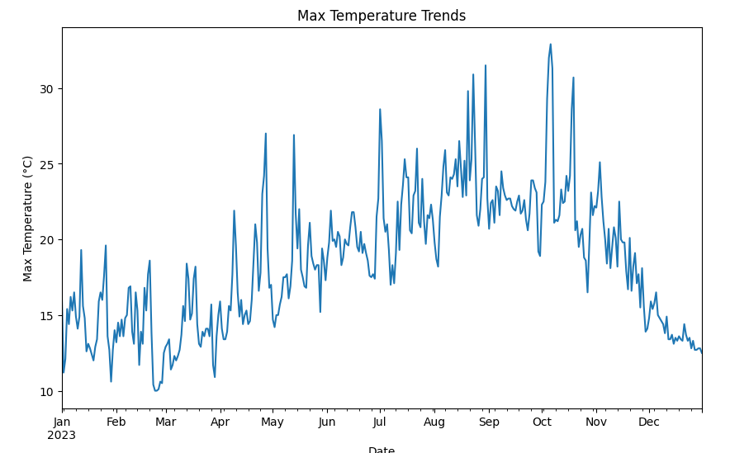

**2. Histogram of Humidity Distribution**

* **Description**: Following the temperature trends, a histogram visualizes the distribution of humidity levels within the dataset. This plot is crucial for understanding the range and frequency of different humidity levels.
* **Functionality**: Generated by the **plot_humidity_distribution** function, this histogram uses Seaborn to create a distribution plot for the **humidity** column.

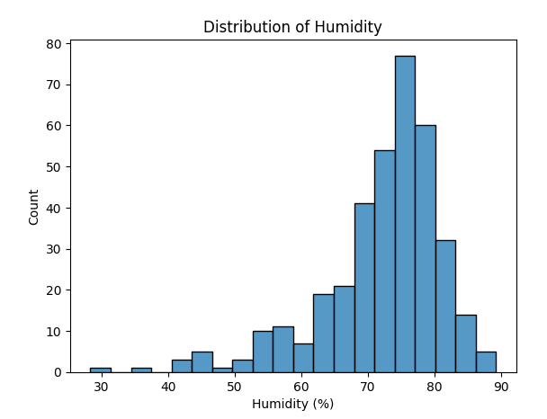

**3. Scatter Plot of Temperature vs. Humidity**

* **Description**: This scatter plot illustrates the relationship between maximum temperature and humidity. It helps in visualizing any correlations between these two important weather parameters.
* **Functionality**: The **plot_temp_humidity_relationship** function creates this plot, showcasing a scatter plot where **tempmax** is plotted against **humidity**.

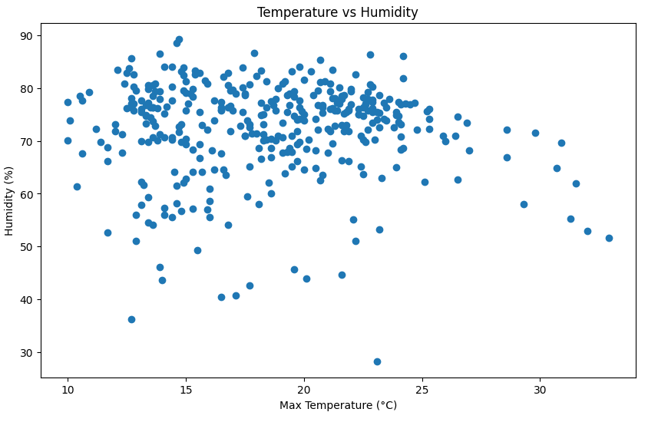

**User Guide for the Weather Pattern Analysis and Prediction Notebook**

**Step 1: System Preparation**

* Ensure you have a computer with Windows 10 or macOS.
* An internet connection is required for initial setup and data retrieval.

**Step 2: Installing Python and Jupyter Notebook**

* If not installed, download and install Python (version 3.8 or later) from [python.org](https://www.python.org/downloads/).
* Install Jupyter Notebook using Python’s package manager pip:

pip install notebook

**Step 3: Downloading the Notebook**

* Download the provided **wguCapstoneML.ipynb** file to a known directory on your computer.

**Step 4: Installing Required Libraries**

* Open a command line or terminal window.
* Navigate to the directory containing the downloaded notebook.
* Run Jupyter Notebook by typing:

jupyter notebook

* Open the **wguCapstoneML.ipynb** file in the Jupyter interface.
* Install any required libraries listed at the beginning of the notebook. This can typically be done by running cells containing pip install commands, like:

!pip install pandas matplotlib seaborn scikit-learn requests

**Step 5: Running the Notebook**

* Execute each cell in the notebook sequentially. This can be done by clicking on the cell and pressing **Shift + Enter**, or by using the "Run" button in the Jupyter interface.
* Ensure that each cell completes its execution before moving to the next.

**Step 6: Interacting with the Notebook**

* The notebook includes cells that perform data fetching, preprocessing, model training, and visualization.
* To interact with the models and view different outcomes, follow the instructions provided in the notebook. This might include modifying input parameters or variables.

**Step 7: Exploring Visualizations**

* Visualizations in the notebook will appear as you run the cells. These include plots like temperature trends, humidity distributions, and scatter plots of model predictions.
* Take your time to examine these visualizations for insights into the data and the effectiveness of the predictive models.

**Example Use Case:**

* For example, to use the predictive model, locate the cell where the model is used for prediction. Follow the instructions in the notebook to input your own data or parameters and run the cell to see the model’s output.

### E. Reference Page

No external references were used in the development of this project. All code and analyses were created independently and are based on general knowledge in the field of data science and machine learning. Standard programming libraries and APIs utilized in this project, such as pandas, seaborn, scikit-learn, and the Visual Crossing Weather API, are widely recognized tools in the field and do not require specific citations.